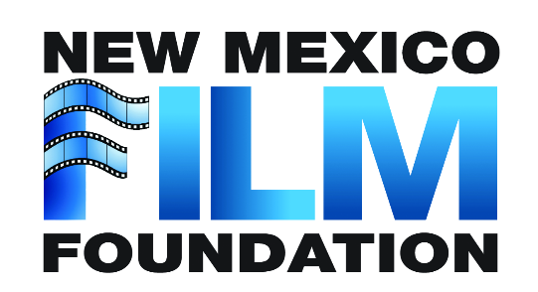

2024 George RR Martin Screenwriting Competition
SUBMISSION FORM

Name: ______________________________________________________________________
Screenplay title_______________________________________________________________
Unique Number: ______________________________________________________________

By submitting this form, I give New Mexico Film Foundation the permission to submit to a panelist of judges the 10 page treatment, 10 page script for purposes of competition for the GRRM $5000 grant issued in 2024.
I attest that the all material submitted is solely owned by me and I release the New Mexico Film Foundation from any liability for use of the material.

Screenwriter

DATE

